THE SINGERS

Jean Mackay

Having been brought up in Thurso, Jean was exposed to Gaelic singing from a young age first at ceilidhs and then through competing in solo singing and instrumental competitions at local and National Mods. Although having Gaelic speaking grandparents from Sutherland she did not have the opportunity to become fluent in the language until she was working in Glasgow where she attended Gaelic conversation classes given by Mina Smith.

While living in Glasgow she was able to join the Glasgow Gaelic Musical Association and enjoyed many years with them before moving north to Inverness where she subsequently joined the Dingwall Gaelic Choir and also revived her interest in Scottish fiddle music by becoming a member of the Inverness Fiddlers.

Jean has attended many classes with Rona over the years both at Ceòlas and at Fèis Rois where she has pursued her interest in both Gaelic Song and in instrumental music. She has also attended various folk music festivals abroad particularly in Scandinavia where she has had the opportunity to tutor classes in Gaelic song and in Scottish tunes.

Along with Jennifer, Linn and Rena, Jean would like to thank Rona for her generosity in sharing both her vast knowledge and repertoire of songs and their history and for the sheer fun we have all had in her classes.

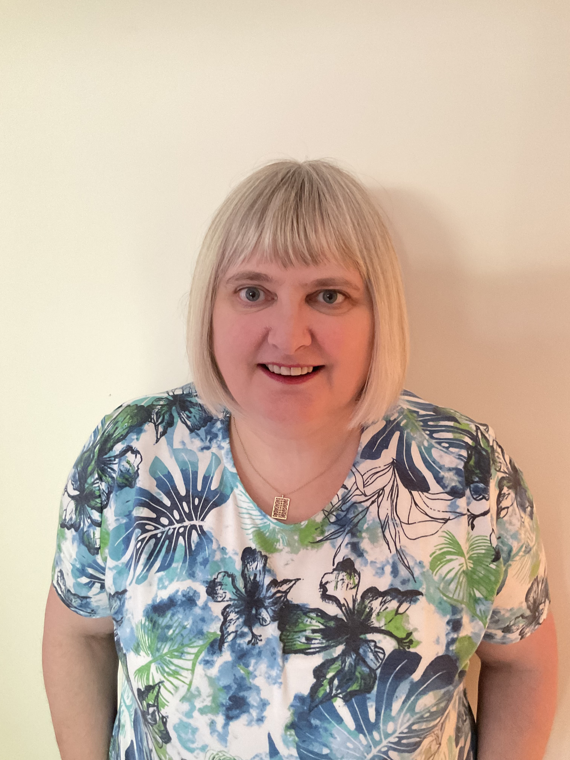
Jennifer Speirs

Jennifer Mary Speirs was fortunate to be brought up in Glasgow in a musical family with a strong interest in classical European music and Scottish folksong.

At university in Scotland she joined a Madrigal Group which led to a lifelong interest in renaissance music and a capella singing, and to continuing friendships as well. Currently she is a member of the Scottish Plainsong Choir and the Early Music Forum of Scotland.

Jennifer had long felt uneasy about her lack of the Gaelic language which was lost to her family during the 19th century, but joining the Lothian Gaelic Choir in the mid 1990s and starting the Còisir Ghàidhlig Chàrlabhaigh in 2012 has provided great opportunities to remedy that. She is also much indebted to Joan Busby, the late Isobel Mitchell, and Kenna Campbell for vocal tuition over the years, and for their encouragement to sing solo.

Along with Jean Mackay, Linn Phipps, and Rena Gertz, Jennifer has attended many of Rona’s classes and has been entranced by her stories and the variety of the repertoire that she has shared so generously.

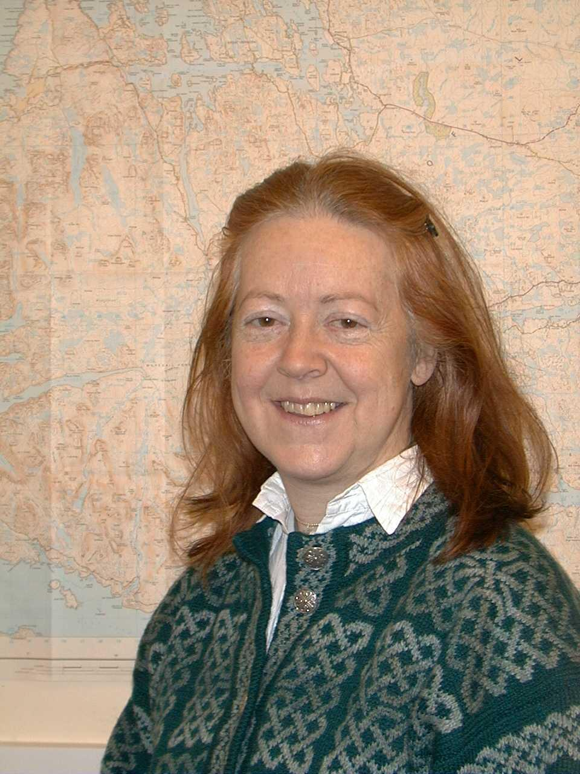

Linn Phipps

Linn describes being included in Gaelic choral and traditional music as the greatest joy of her life. Family legend is that she first sang a Scottish song at the age of four, no-one remembered what! Like other traditional singers, Linn has built a repertoire over the years based on a mix of song classes, books, competitive singing, and tutor/friend recommendations, and she particularly appreciates the support she has had from her Stornoway tutors Alma and Chrissie, and along the way many others like Annie MacLeod.

Rona’s song classes – at Fèis Rois and Ceòlas – have been a particular joy. Punctuated with stories and much laughter, not to mention hard learning work – once experienced, they are never forgotten. At her first Ceòlas, Linn was joined by her daughter Katie, and they both first met Rena. They all laughed so much that Linn had to hold onto things to stop from falling over!

For Linn, the pinnacle of Rona’s classes were the two at Fèis Rois in 2015 and 2016, for young pipers to learn piping songs, canntaireachd and the related pibrochs. Despite wanting from the age of 7 to learn bagpipes, this was not allowed, and Linn can’t play anything at all! However, she contacted Rona’s husband Tony to ask to PLEASE join the class. Rona said yes. For Linn, the classes and the listening were just fantastic, like… sunbathing …

The idea for this recording derives from when, a year ago, Linn was stuck at sea in Antarctica, as Covid swept the world, and unable to get home. Sorting and indexing Rona-recordings, she thought – why not record Rona’s piping songs, link them up with piping and with Rona’s own amazing story? Rona was delighted with the idea, and the rest is … history. Besides raising her family, Linn describes her greatest life achievements as winning the Silver Pendant at the Royal National Mòd, and gaining a Gold Card for Gaelic fluency. Probably producing this double CD will be her third!!! Ceud mìle taing don a h-uile duine.
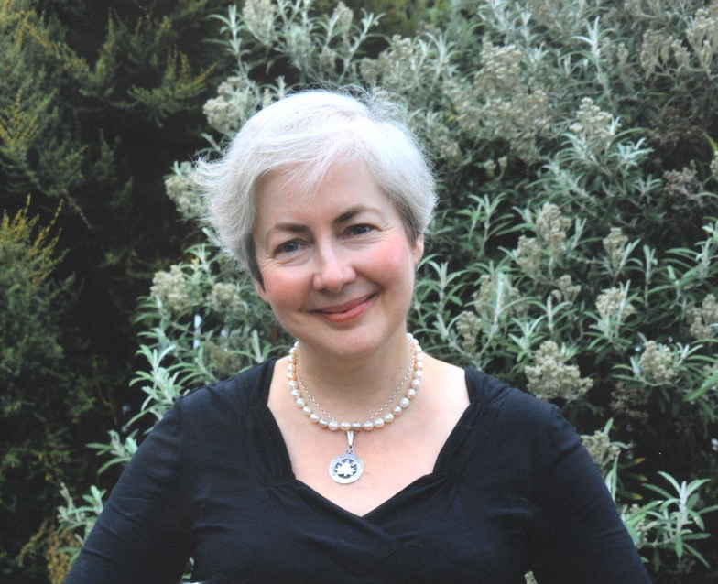
Rena Gertz

In 1996, Rena came to Scotland to complete a Masters Degree in law. Writing her dissertation during the summer, she was looking for something to do during the evenings and discovered that Aberdeen Gaelic Choir was practicing on Tuesday nights. Curious, she went along and, as they say, the rest is history. She fell in love with the beautiful music, joined the choir and, staying at the university to do a PhD, attended undergraduate Gaelic classes to find out what the songs actually meant.

By then she had decided to stay in Scotland to live, and when she moved to Edinburgh for her first job, she joined Lothian Gaelic Choir. There, people encouraged her to attempt solo singing. Since then, Rena has been taking singing lessons, first with the late Isobel MacDonald Mitchell and currently with Magdalena Durant, and has become really passionate about singing in her native language of German, in Gaelic and lately in Italian. She now sings with Glasgow Islay Gaelic Choir, in the Glasgow Ballad Workshop and with a traditional Scottish-Irish band.

In 2004, Rena travelled to South Uist for the first time to attend Ceòlas, the Gaelic summer music school. There she joined a song class taught by Rona Lightfoot and became fascinated by Rona’s wonderful treasure trove of songs and her engaging way of teaching. Rena now regularly goes to song classes taught by Rona, both at Ceòlas and at Fèis Rois in Ullapool.

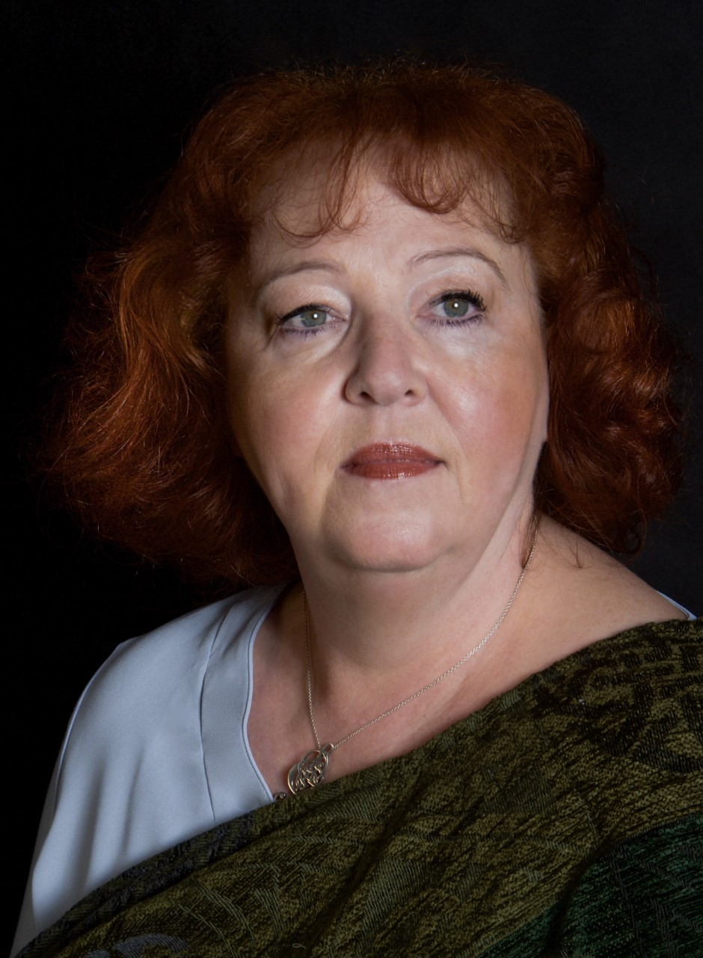
THE PIPERS
Ashley MacDonald

Ashley MacDonald hails from Uist, Gearradubh, Grimsay and Island Flodda, Benbecula. Ashley is a descendant of many great pipers and accordion players from all over Uist including Rona’s cousin John MacDonald and Roderick MacDonald of South Uist.

Ashley began playing at the age of 9 and has won many competitions locally and nationally gaining many’s a title. Ashley meantime resides in Lewis with her daughter Lucy Anna who is also learning the Chanter.

Ashley is the piping instructor for the Lewis and Harris schools as well as the Director of the Lewis and Harris Youth Pipe Band. Currently the Western Isle boast a great female role in piping as there are three female Piping instructors covering the Island. Esther MacDonald, Anna Murray and Ashley MacDonald.

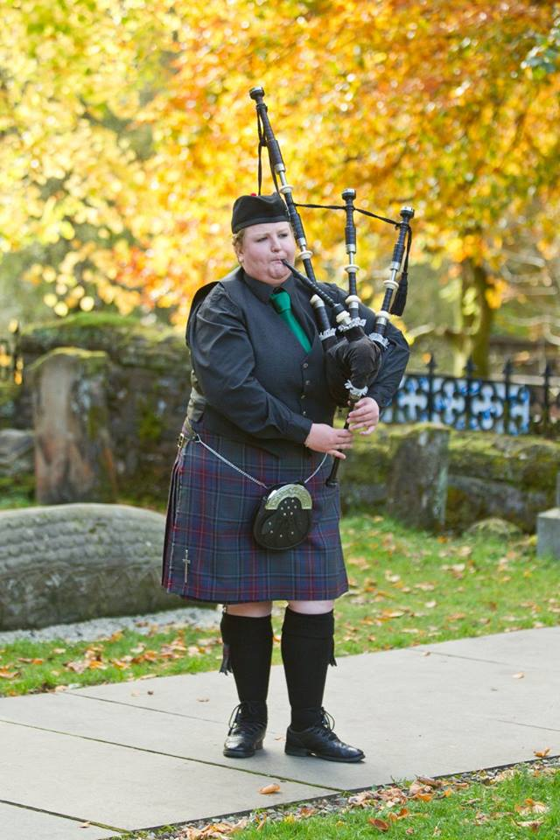
Calum Alex MacMillan

Calum Alex Macmillan comes from a long line of tradition bearers and was born and brought up in the Isle of Lewis in a Gaelic-speaking community. He received piping tuition from the world famous Pipe Major Iain Morrison, and is also a prize-winning traditional singer.

Following the release of his first solo album ‘Tàladh nan Cuantan’, Calum Alex spend six years with the award-winning Highland band Dàimh.

2017 saw the release of his second solo album, ‘Till’, meaning return, a reference to his living away from Lewis just now. https://www.verticalrecords.co.uk/product/calum-alex-macmillan-till/

As well as undertaking solo and collaborative performances, Calum Alex works as the Development Manager of Fèisean nan Gàidheal. This is the independent umbrella association of the Fèis movement which supports tuition and participation in traditional Gaelic arts for young people across Scotland (https://www.fèisean.org).

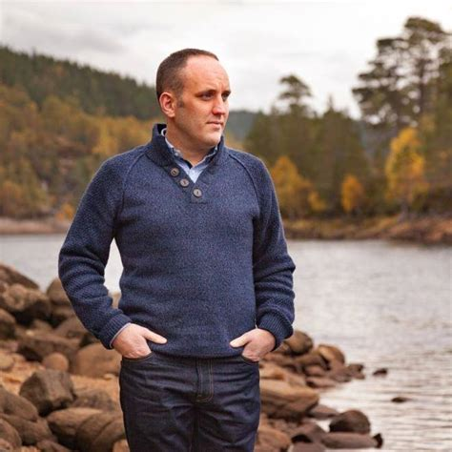
Duncan Nicolson

Duncan started playing the pipes at the age of 9, taught by his father Donald. He then got lessons from PM Evan MacRae and was a member of the Lochaber Schools Pipe Band.

Duncan has played in various folk bands including “Train Journey North”, “Canterach”, Skipinnish and the Vatersay Boys.

A change of career came in 2001 joining Strathclyde Police as a police officer and joining the pipe band. He has been a member of the band in its various names since then and having served as Pipe Major from 2010 until 2015. He still remains a member of the band as the current Pipe Sergeant.

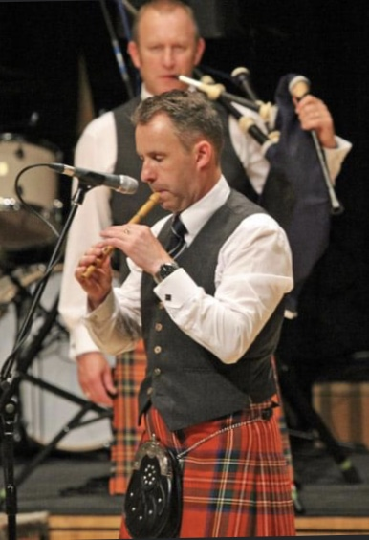
Iain Speirs

Iain Speirs was taught to play by Jack D. Crichton, his father Tom Speirs, a Gold Medallist and Clasp winner, and by his grandfather Jock Speirs, Pipe Major of the London Scottish and Johnnie Walker Pipe Bands. Iain has also previously received tuition from Donald MacPherson and Murray Henderson.

Iain is a double gold medallist, two time winner of the Clasp at the Northern Meeting and won the Glenfiddich Piping Championship in 2012 and 2013.

Iain lives in Edinburgh with his wife Susanne and children Annie and John. He works in financial services marketing.
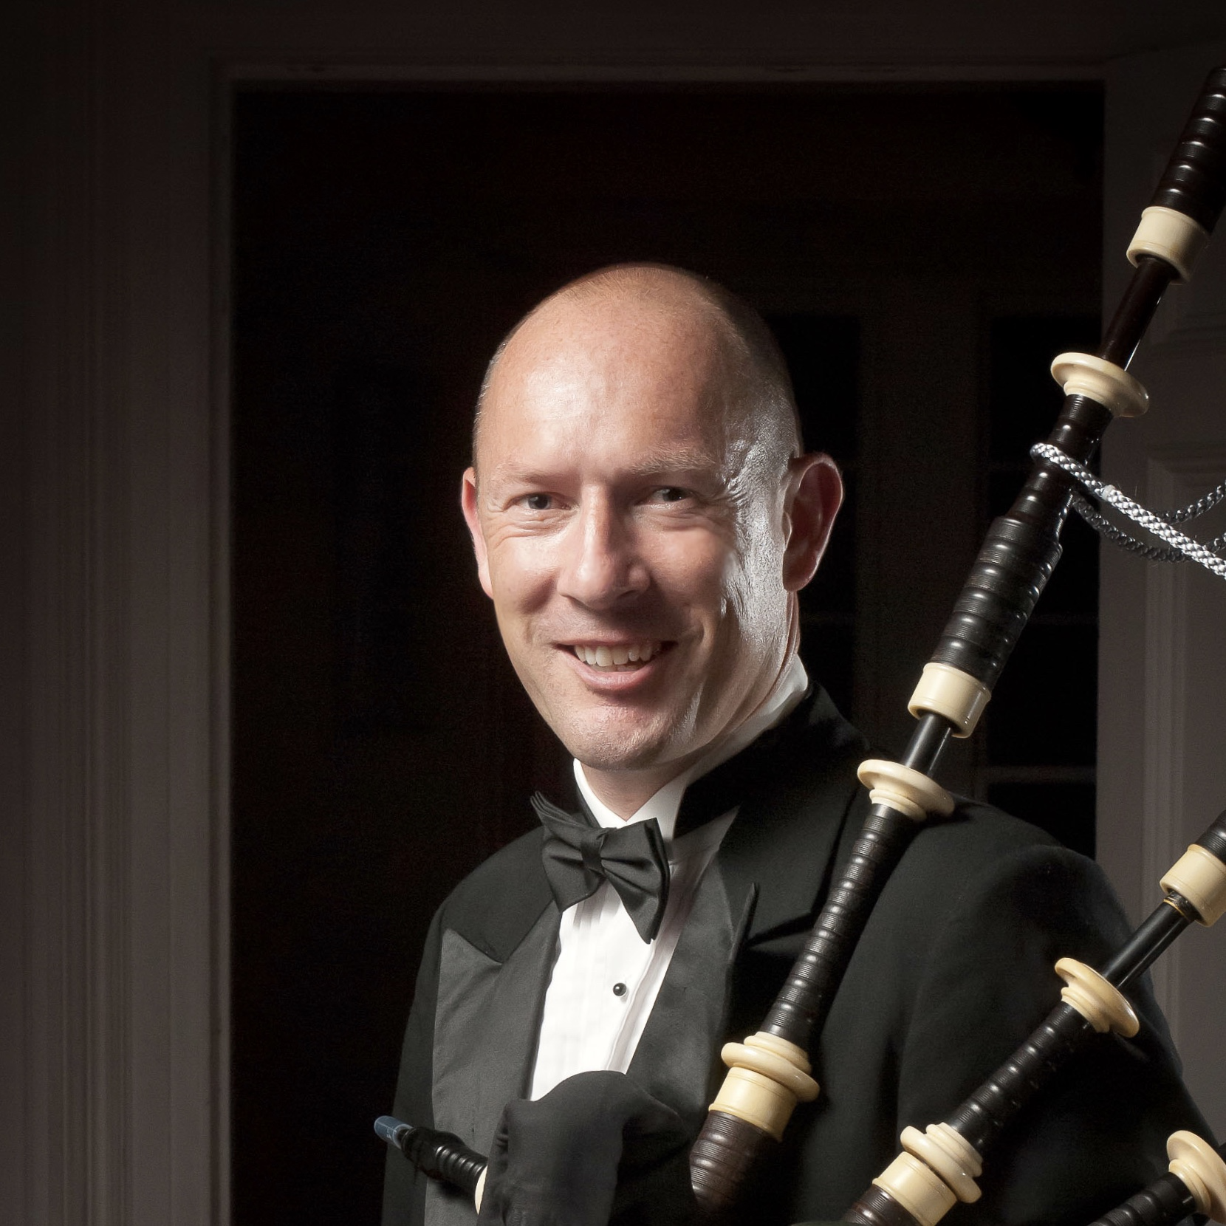
Photograph by Derek Maxwell.

Michael Grey

Michael Grey received his early lessons at thirteen from George Walker of the 48th Highlanders of Canada and was a member of this illustrious band for three years. He studied under John Wilson, one of the twentieth century’s greatest players, and received extensive tuition from Bill Livingstone, John Walsh and Captain John A MacLellan.

He has four times won the North American Championship, the overall title at the Vancouver Indoor Meet twice, the Piobaireachd Society Gold Medal (Canada) and that venue’s March, Strathspey & Reel and Former Winners’ MSR on the same day. He also holds the aggregate championship at the Cowal Highland Gathering, previous winner of the Scottish Piping Society of London’s Strachan Cup and the Metro Cup (USA). He has seventeen times won the professional Ontario Championship Supreme awards for both piobaireachd and light music. He is a four-time winner of the Toronto Piper’s Society Knock-Out final.

He has published seven books of pipe music and has released nine recordings. He was a founding member of the 78th Fraser Highlanders Pipe Band and was a member when they became the first non-Scots band to win the World Pipe Band Championship. He was Pipe Major of the Peel Police Pipe Band from 1995-99, Pipe-Sergeant of the Toronto Police Pipe Band from 2007-13. He sits on the judging panels of both The Pipers’ & Pipe Band Society of Ontario and Solo Piping Judges Association (Scotland). He is currently a member of the Glasgow Police Pipe Band and President of The Pipers’ & Pipe Band Society of Ontario.

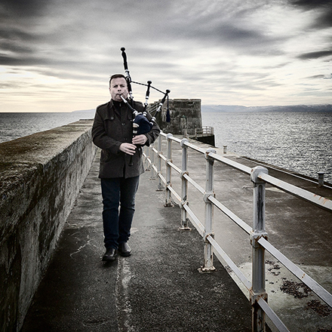

THE NOTES ON PIPING TUNES AND PIBROCHS: PROFESSOR JOSHUA DICKSON

Professor Joshua Dickson is Head of Traditional Music at the Royal Conservatoire of Scotland. In partnership with the National Piping Centre, he led the design of Scotland’s renowned BMus curriculum for the Highland bagpipe. Josh is the author of When Piping Was Strong: Tradition, Change and the Bagpipe in South Uist(2006) and has brought to light the role of women in the inheritance and transmission of traditional Gaelic canntaireachd in Hebridean life in ‘Piping Sung: Women, Canntaireachd and the Role of Tradition-Bearer’ in the journal Scottish Studies (2013).

